Decolonising the Digital Rights Field in Europe:

An Outline Draft

Digital Freedom Fund (DFF) and European Digital Rights (EDRi) are inviting feedback on the Outline Draft of the Decolonising the Digital Rights Field in Europe Programme.

This document is one outcome of a two-year process of collective design with 30 participants from racial and social justice and digital rights, hoping to address power dynamics in the field and imagine a vision for anti-colonial digital futures. It is the result of the collective work of the participants in the process.

As such, this Outline is a draft of the decolonising programme we hope to present in further versions of later in 2023. It is not perfect nor complete. It's open to changes and new additions. This outline will undergo a series of consultations with communities, individuals, collectives, organisations who were not part of the original process. We hope to critique, build, and develop on these ideas, hopefully getting closer to an ambitious, disruptive, imaginative agenda of decolonisation. We also recognise that – as we define decolonising as a process – the end programme may undergo evaluation and iteration after a certain implementation period.

This draft and the collective process behind it – reflects the positionality of its participants. Many of the participants have a European scope of work or work targeted at the European decision-making spaces. The process did come out of – and remains linked to – the digital rights field. This encompasses activists and organisations who work to promote and protect human rights and social justice in the digital age. A field that looks at the societal impacts of digital technologies.

The document is intended for anyone interested in working toward structural changes in digital rights work and organising, with a specific goal to ensure the work serves communities most affected by digital harm. We invite insights from a range of disciplines, including reflections from the European digital rights field itself as to how they see their own roles in implementing and engaging with this process. We are eager to hear from you and, in advance, very grateful for your feedback.

The Outline Draft is structured in three sections:

- Decolonising and Frameworks of Shifting Power: outlining how we understand decolonising for the purpose of this process, and what frameworks we are using to measure shifting power
- Decolonising Digital Rights Outline Programme: detailing the structures, activities and processes we propose to move toward structural change in the field. Those elements are organised under four directions: (a) Imagining through collective, community research (b) Organising transnationally (c) Repairing, redistributing and supporting movement, and (d) Building solidarity through peer-support.
- Next steps and transition plan: where we briefly outline where the process will go next.

I. How do we understand decolonising? Frameworks of shifting power

The process was intentional about using the term decolonising to reflect that present technology-powered injustices and oppression have their roots in a history of domination and colonisation and are maintained by structural forces.

Our goal is to initiate a process that challenges the structural causes of oppression in order to work towards a digital rights field that centres justice in society.

The content of this programme builds on a legacy of Black and afro-feminist thought and praxis of Afro-futurism, anti-colonial processes of visioning, knowledge production from the global south, abolitionist concepts of dismantling and re-imagining, ethics of trauma-informed organising, critical reflections on funding and philanthropy, and contestations of capitalist extractivism. We understand this work to be a project of world-making:

"Decolonization does not go unnoticed, it can’t; its world changing, world ending, and world-making. Decolonization is a historical process that dethrones Euro-Western thought & practice as the standard & primary (theodicy) for existence."
Dr Shay-Akil, Decolonize All The Things

The process is intended to be ambitious and radical. Yet, it exists within other realities that go beyond our vision and reach – realities of political decision making, philanthropy, civil society structures, and broader structures of oppression. How would we know, then, that the process has contributed to the above-mentioned goals?

What measures do we use for decolonising, of shifting power? In what framework have we been designing this programme so far?

Whilst we recognise shifting power can take many forms, in shaping the programme we have focused on the following three elements, to substantiate our understanding: healing and reparations, imagining, transforming, changing, and, fundamentally, the re-distribution of resources.

- By healing and reparations, we mean that all decolonising processes must engage with clear material and symbolic reparations towards the communities and lands that have historically been stolen (from) and exploited by colonial dynamics. It also recognises that colonialism and coloniality produces trauma and untimely death and that all anticolonial practices must therefore centre healing to transgress this violent framework.
- By imagining, transforming, changing, we mean that colonisation killed many worlds, as well as the possibility of remembering and/or imagining them. Decolonising therefore necessarily means imagining entry points into new worlds outside of the current status quo, by testing and failing and daring again and re-adjusting delicately and/or suddenly.
- By redistribution of resources, we mean that colonisation produced a structural unequal access to vital resources and a destructive relationship to sentient and inanimate beings. Decolonising means creating the conditions to fair and life-affirming access to resources for all by changing drastically how resources get accessed and who decides.

We use the term “transformative” frequently. By that we mean processes in capacity to challenge the status quo and create, amplify and/or better alternative spaces and practices, rendering the current oppressive realities obsolete.

We attempted to find indicators for shifting power to guide us in the move to radically change power dynamics. Some initial indicators identified were:

- Shift in decision making roles towards structures of shared power (in accountability, pay structure, representation etc.)
- Recognition and compensation of emotional and care labour and added burden of transformative work on members of marginalised communities
- Collective processes regarding allocation of resources power as to where funding goes and for what)
- Existence of structures of accountability to prevent and repair structural oppressions
- Existence of processes to ensure work is community powered and centred (centring lived experience and community expertise)
- Commitment to processes to build power separately from oppressive institutions

There are likely to be many more indicators of shifting of power, and as such a more complete framework of shifting power is one of the proposed elements in the programme.

II. Creating a new ecosystem: The Decolonising the Digital Rights Field Outline Programme

The programme forms a cycle in which all parts feed into each other to create an ecosystem, allowing for new questions, needs and responses to emerge. This format recognises that decolonising is a process – not a one-time event. It therefore centres the values of fumbling and failing as a way of making progress and creating multiplicity and acknowledges the worth of collective ways of thinking, deciding, creating and doing.

Decolonising the Digital Rights Field in Europe, an ecosystem:

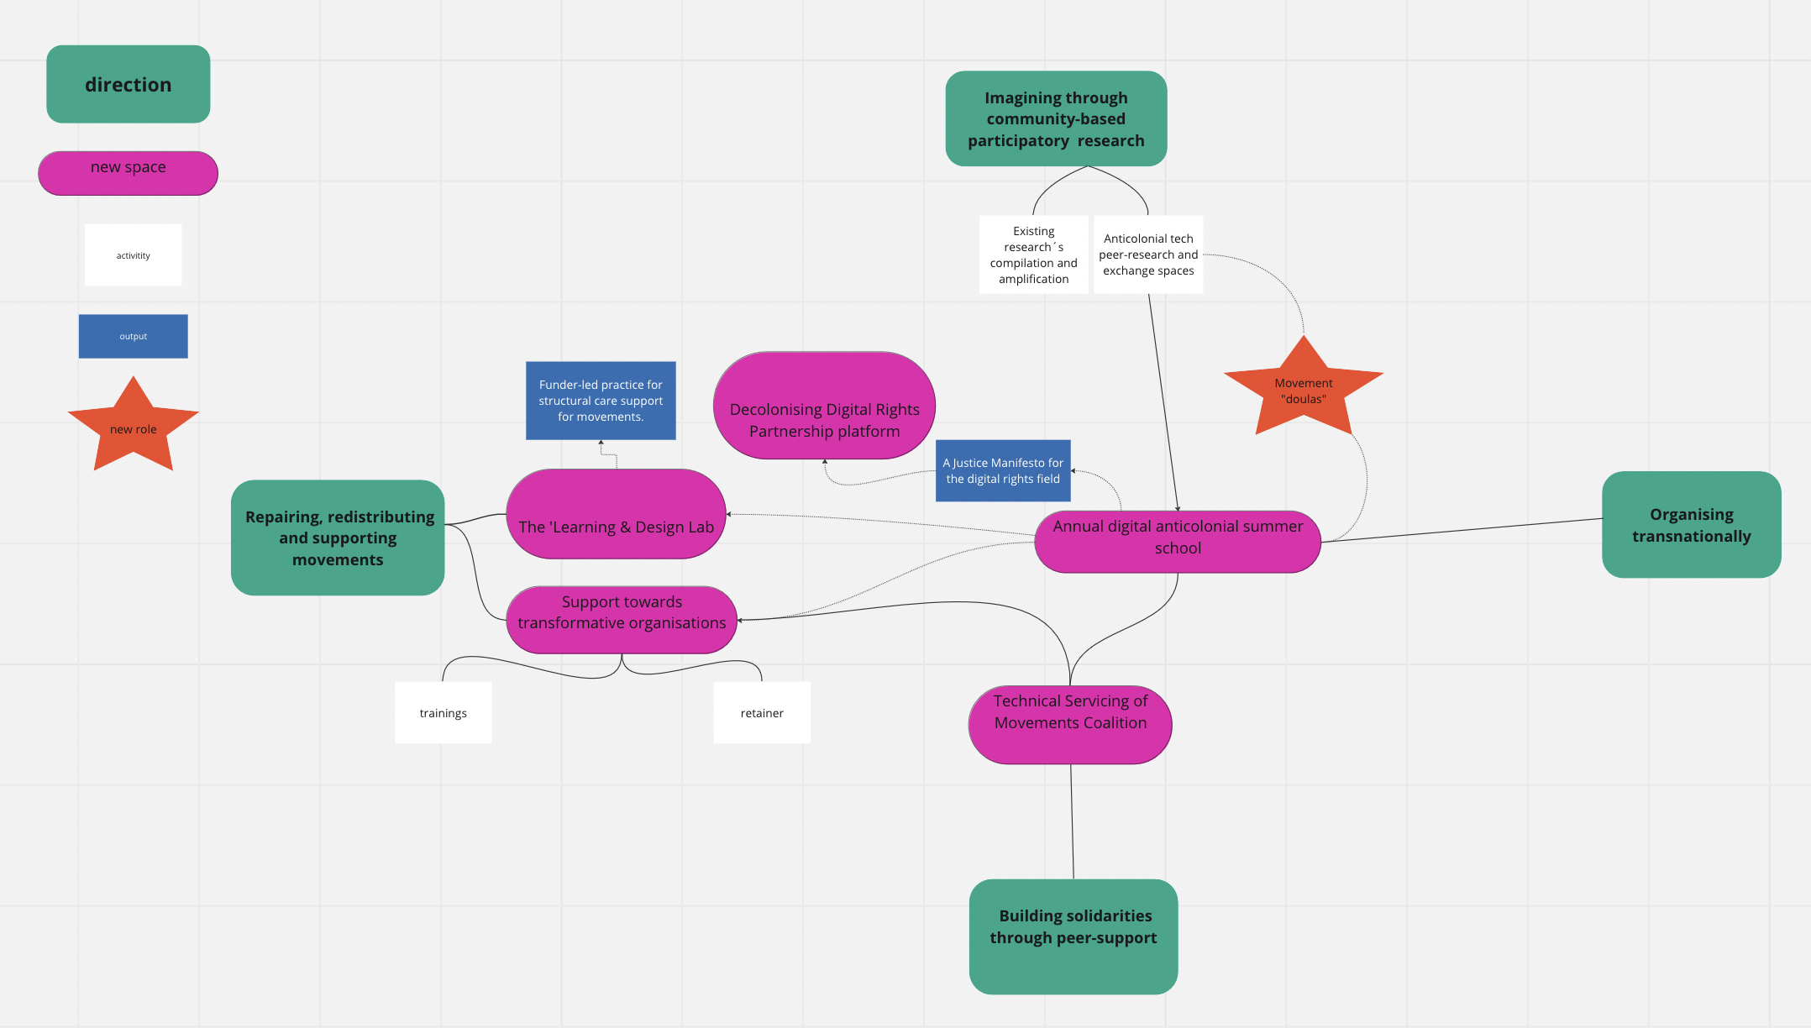

Figure 1: Diagram of the Eco-system of Decolonising Digital Rights Elements. Credit: Laurence Meyer.

Whilst not a finite space or ‘end-goal’ in itself, the ecosystem is made up of organising spaces (summer school, lab, peer-exchange clusters and a technology skills exchange), new roles (doulas) and community tools and outputs (manifesto, repository, research, frameworks etc). Below, we structure these elements under the four general directions we have identified as important to keep in mind while navigating the ecosystem.

- Imagining through collective, community research
- Organising transnationally
- Repairing, redistributing and supporting movement
- Building solidarities through peer-support

In terms of the content, the programme seeks to acknowledge the importance of movements and the centrality of movement-building to bring about transformative change, with spaces for transnational organising, the digital anticolonial summer school (DASC) being at its heart. As a way to subvert and inspire the policy agenda of the digital rights field, a digital justice manifesto will emerge from the summer school setting out the priorities that supports movements powered by communities most affected by digital extraction, surveillance and discrimination.

We envisage structural change to be informed by processes of imagining through collective, community research. Through their participatory and community-centred methodology, the research aims to reinforce community-building and ensure that relational work is at the core of any knowledge produced. This will allow for connections and longer-term work with participants of the DASC. The participatory community-centred research will also feed into the sessions around partnership practices, learning and needs, the yearly agenda setting of programmatic priorities, and the coalition of grantees work, all of which have already been mapped by the process as initials building blocks of the digital anticolonial summer school. The research will dig deeper into how structural change in the field can occur, in terms of support of anti-oppression movements, redistribution, reparation and healing.

To ensure that communities and movements most negatively affected are actively supported, several elements are proposed around repairing, redistributing and supporting movement. The learning and design lab is proposed to initiate structural change in the allocation of resources in the field. It will ensure a continuous space for learning and holding the philanthropy system accountable to servicing movements seeking radical change. Various forms of support are proposed to better resource movements resisting oppression in the digital space, as well as creating anew.
Movement doulas (also shaping the DASC) will work to map and help new movements to connect with digital issues, as well as new potential connections and avenues to surface.

Finally, we include elements geared toward building solidarities through peer support, in particular using resources and skills already existing in many movements. We present ways that activism on digital issues can be better shaped by principles of solidarity and mutual aid, including how those with access to skills and resources on transformative technologies can better service anti-oppression movements. These connections will also be fostered at the DASC, and via the partnership platform.

I. Imagining through collective, community-centred research

Research is needed to investigate both how technological harms are embedded in coloniality and how they manifest, and explore anticolonial ways to resist and reimagine the worlds we want.

When we speak of research, we speak to participatory processes of knowledge production that are rooted in and led by communities, rather than static, linear products. We see the research for this project happening in two stages:

1. Compilation and amplification of existing research making their content more widely accessible. It will also mean enriching them in some cases.

2. Developing process of new research and knowledge production to fill the gaps in tech-harm mapping and documentation and support transformative imagining and goal setting for desirable and just tech realities.
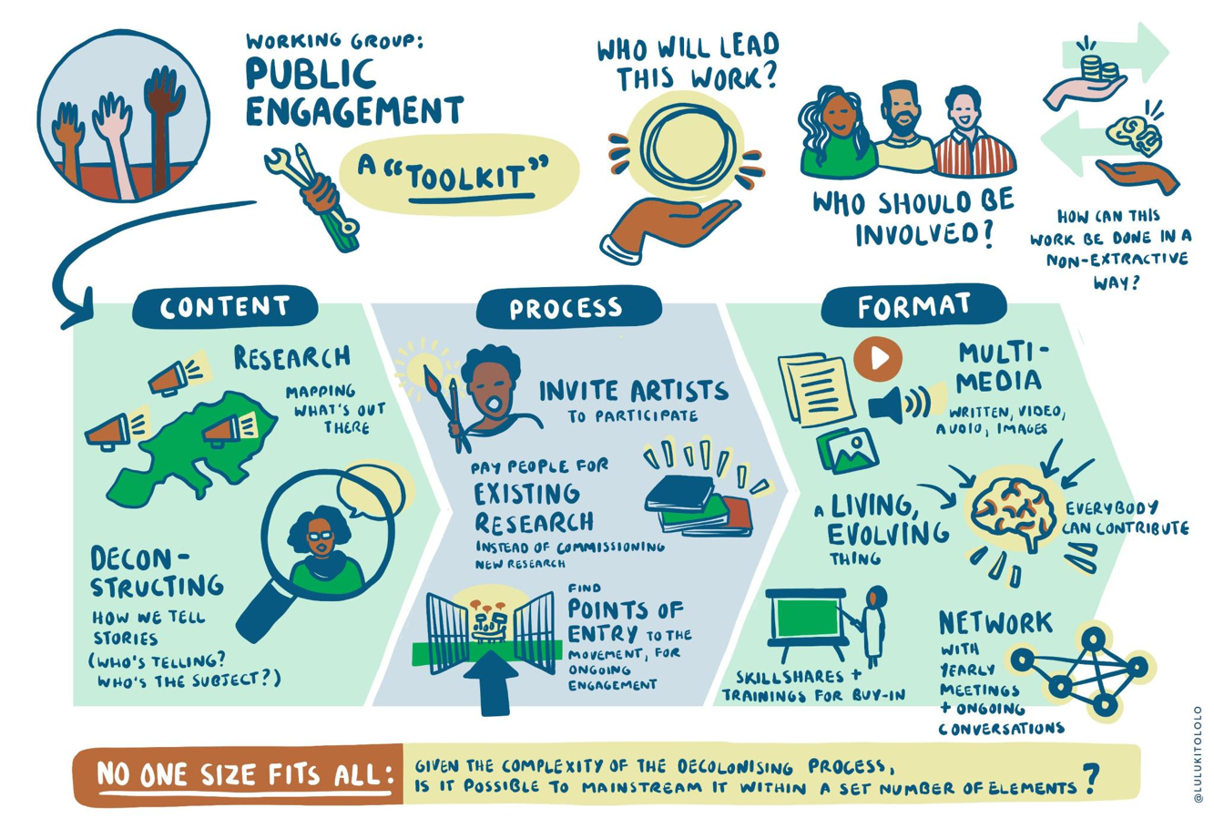

Figure 2: Graphic Recording of the Public Engagement Working Group. Credit: Lulu Kitololo

1. We have identified the following first areas of research projects in which compilation and amplification of existing research could start:

- Mapping of transformative mental health supports available in Europe. Colonial dynamics are first and foremost a health crisis impacting our physical and mental health. Specifically for people from marginalised communities – the workplace can often be a space that negatively impacts their mental health, disabling them to do the work. This also has implication in the possibility of staying in a position, particularly when the position implies being an expert on subject such as race, gender, queerness, poverty, migration status and/or disability justice. The research will aim at map the resources available in Europe that organisations can use to support their employees in a trauma-informed way.

- Research on the colonial roots of digital rights funding in Europe. Specifically, this would explore the colonial and extractivist roots of the funders operating in the European digital rights field and present a series of recommendations on how such funders could provide reparations.

- Repository of anticolonial, abolitionist and/ or transformative movements in Tech. Many movements, organisations and researcher are already organising and creating practices and research around digital technologies within anticolonial, abolitionist and/or transformative frameworks. The repository will aim to amplify their reach and support their archiving.

- Framework of indicators for decolonising. A framework for shifting power to be developed by activists, communities and collectives in racial, economic, social and digital justice. This framework would serve as a tool for self-assessment for funders, civil society and others when implementing activities in this programme, or other new initiatives, projects and partnerships seeking to address and dismantle structural power imbalances.

- Transformative partnerships framework and mapping of successful transformative partnerships. Recognising that coalition-building and relational work are technologies and knowledges- this piece of research will explore how to build meaningful coalitions on social, racial and digital justice. This will be a community-driven research and evaluation into how partnerships are formed according to principles of meaningful solidarity, anticolonial and feminist understanding of multidimensional forms of oppressions. Mapping examples of successful transformative partnership practices as inspiration, the research will produce a community guideline which will serve as a tool and set of reflections for actors looking to build partnerships within and with other movements, in particular in circumstances where there is a power imbalance (for example in terms of access to resources) between the organisations involved.

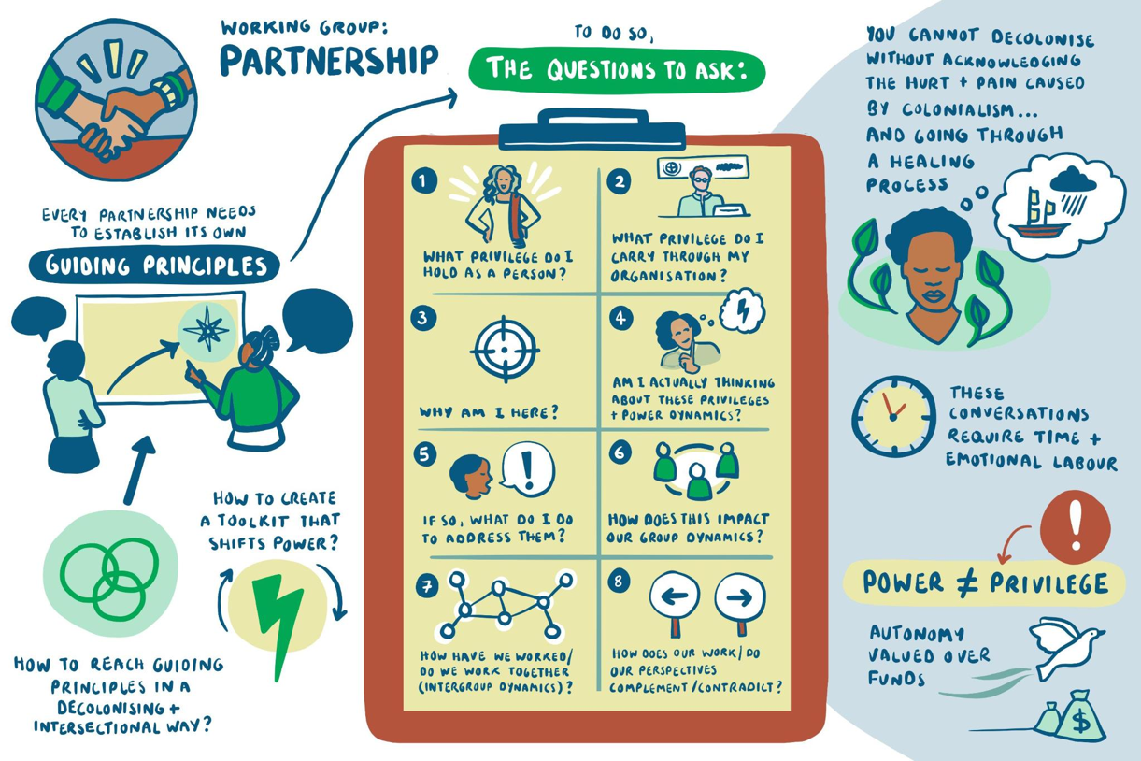

Figure 3: Graphic Recording of the Partnership Working Group. Credit: Lulu Kitololo

2. The programme also foresees new spaces dedicated to community knowledge via anticolonial tech peer-research and exchange & production spaces. These spaces will allow for community-based knowledge to be produced around key themes of digital justice issues with organisations of impacted communities driving the scope of the research, the form it takes, as well as producing the content. The participants will be compensated for their time. Those spaces will not be one shot workshops but rather create multiple meeting points for continuous reflection and exchanges in a rhythm allowing for different groups to participate. It could include for example Black feminist and Roma feminist spaces, among many others, in which question of economic, social and environmental oppression would be explored in relation to Tech. The result might take different forms such as audio recordings, fanzines, videos, short texts or eventually nothing. Those peer-research spaces would involve mental health, connection and artistic practices for the participants.

II. Organising transnationally

1. A Digital Anti-Colonial Summer School (DASC). This annual gathering will centre how to build sustainable, strong connections and community building amongst those contesting digital harm through workshops regarding both digital rights priorities and strategies as well as transformative organisational, partnership and funding practices.

The DASC will be collectively developed during which racial, social and economic justice organisations will set the agenda for digital rights work. The gathering will ask and seek to answer the question or how can digital rights service social, racial and economic justice? What are the key issues, struggles, and visions that a digital rights movement centring marginalised communities should prioritise?

2. A Justice Manifesto for the digital rights field. Participants at the Digital Anti-Colonial Summer School (see previous point) would develop and publish a joint manifesto on digital issues to outline its positive vision for digital justice. This manifesto would be of use to engage funders, policymakers and civil society in the digital rights field, highlighting the issues and solutions identified by the participants of the DASC.

3. Decolonising Digital Rights Partnership platform. This platform would collate information and facilitate collaboration, participation to future events, redistribution of resources in the digital rights field. It would inform collectives and individuals, especially from outside the traditional digital rights field to access opportunities for support or collaboration from the existing field, opening up resources, expertise and solidarity and informing about the implementation of the activities set out in this decolonising programme. It will provide a space for them to apply to become part of the initiatives we will detail in the programme, and others externally.
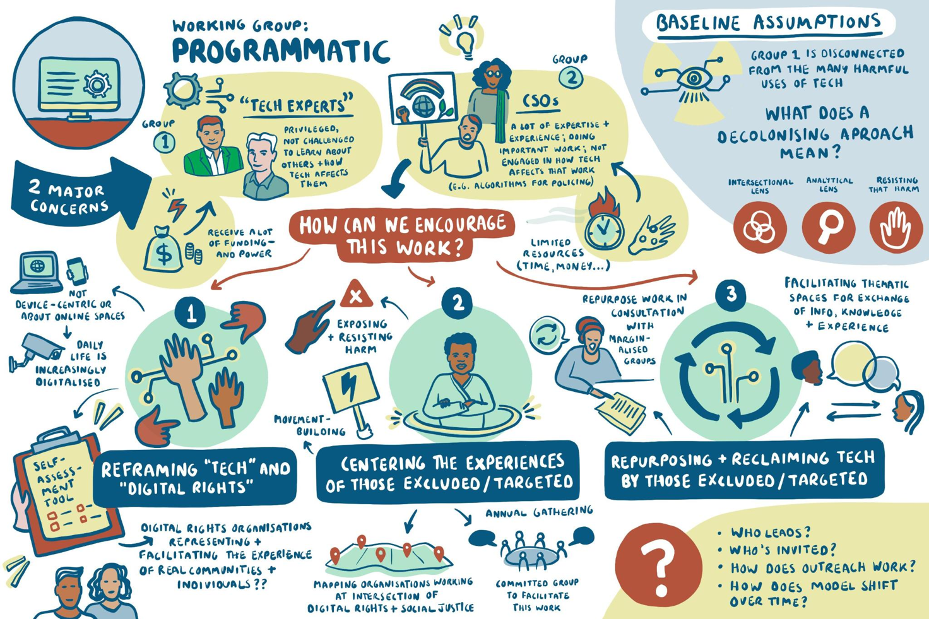
Figure 4: Graphic Recording of the Programmatic Working Group. Credit: Lulu Kitololo

III. Repairing, redistributing, and supporting movements

1. Funder-led practice for structural care support for movements. Funders participating in the Learning and Design Lab would develop and publish a set of community guidelines for how they will commit to supporting wellbeing, equity access and care work support for marginalised communities and people with specific needs due to structural inequality. This would include making available specific funds and processes to support accessibility infrastructure, funding care support, access to prayer spaces, child and other caregiver’ support, healthcare, including mental health support, access to gender-specific services, income support for activists etc.

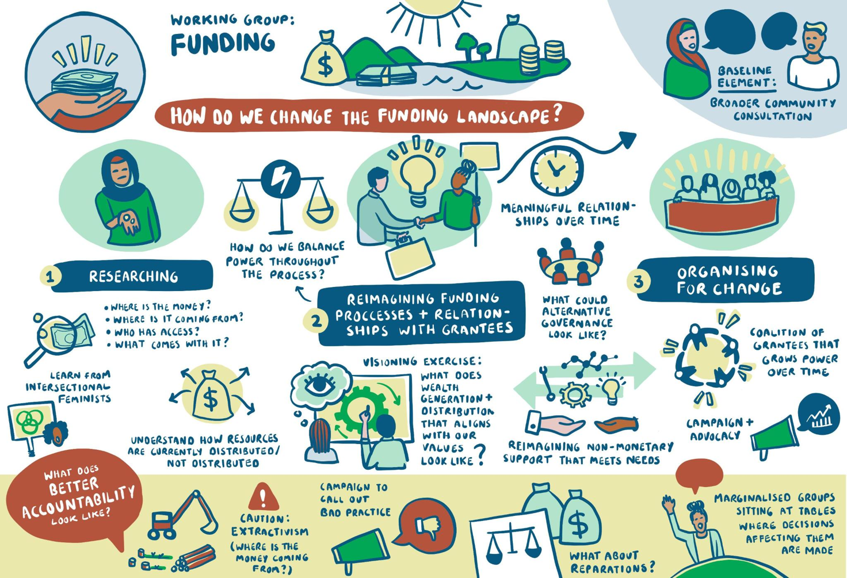

Figure 5: Graphic Recording of the Funding Working Group. Credit: Lulu Kitololo

2. The 'Learning & Design Lab' (LDL) would aim to hold space for funders, grantees and community experts from larger movements to work together to learn, design and pilot new approaches to distribution of wealth and other forms of power to sustainably resource the self-determined priorities and activities of communities impacted by funding decisions.

The LDL’s objectives would be refining the role and engagement in the funding relationship and reimagine funding processes to dismantle the power relationships that dominate it. In more detail, we would imagine the LDL to develop processes for the reimagining of:

- application process (pre-funding) incl. Infrastructural support to aid applications (e.g., language support and other types of support etc)
- composition of funding institutions to be more participatory, relational and involve meaningful devolution of power to communities
- post-funding relationship and dynamics (e.g. exiting funding) (post-funding)
- learning and impact evaluation (pre-, during and post funding) that is mutually beneficial and can be practically integrated into future decision making on all ends (for both funders, organisations & movements)
- forms of non-monetary support (during funding and after funding has ended) e.g., network, skills, capacity building, tech and tools.

3. Movement doulas facilitating connection between social justice and digital rights. Our design work highlighted that many of the connections in digital rights and social justice came when key persons or organisations with experience in social justice worked to make connections with digital groups. Movement doulas would play an important role in building bridges between community-based organisations and digital rights organisations, and developing new networks/channels for thematic exchange, with a focus on social justice issues rather than the technology per se. The doulas will be funded positions where people or organisations with experience in specific social justice spaces work to forge alliances between digital rights and social justice movements, and in particular support social justice orgs to build their work on digital issues, and how they affect their communities.

4. Support towards transformative organisations. Only sustainable organisations with strong anti-oppressive to transformative processes and practices, rooted in strong antiracist and transfeminist knowledge and expertise, can create workplaces capable to bring about durable structural anti-colonial changes. All organisations are different, with a variety of size, budget, existing structure, existing policies, types of donors, and target objectives, among others. To account for this, a decolonising process must be individualised for each organisation or collective. It will take both the shape of a series of training and peer-support spaces, as well as a retainer. As such, the programme proposes a facilitated capacity building and organisational development process, led by an outside facilitator. This support will centre primarily the needs of racial, social and economic justice organisations working on digital rights issues, but would be beneficial for all organisations committed to transformative change. The process will include conversations on:

- Governance and leadership
- HR policies and staff manuals, including pay, leave, caregiver policies
- Accountability infrastructures within organisations
- Sharing power, decision-making and consensus building
- Mental health and wellbeing

IV. Building solidarity through peer-support

1. Technical Servicing of Movements Coalition. Building a coalition of people with technical and digital skills in digital rights spaces to organise and offer support and skills trainings to grassroots social justice movements. This could include support with long- and short-term projects, offered in solidarity with other justice movements. These skill shares could be published on the online platform (see section II) and the support offered could include building and maintaining that online platform.

III. Next steps and transition

There are many things missing in this outline draft, which we hope to build on and collectively shape with a wider community of people during the consultation conversations. We see the building of the decolonising programme as iterative and collaborative and so will review and incorporate feedback at various moments, engaging and working with accountability to the core participants to the process and the new contributors we engage along the way.

Beyond the consultations, we will work toward a longer-term transition plan for how this work will be collectively implemented and owned. Our hope is that the fruits of this collective design can continue to engage more communities and organisations, especially those most affected by digital discrimination, surveillance and extraction.

While we acknowledge that EDRi and DFF want to be involved in the programme implementation, these organisations are very different in nature, and considering their power and position in the field, may not be the best placed to lead this process on the long run. We know organisations that have a long tradition and extended knowledge and practices of anti-colonial, antiracist, queer, transfeminist, anticapitalist organisational work are the ones who are best place to take it further.

Referencing and commitments

In the consultations, we make the commitment to honour the time and knowledge shared to us by contributors. As well as offering to compensate those who enter a conversation with us, we commit to a transparent citation of those who contributed to the ongoing development of the programme.

In a similar vein, we ask that those reading this outline draft acknowledge that the ideas contained are the product of two years of collective work by the participants to the process. As such, we ask that it is referenced accordingly when the material is used.

Influences and Inspirations

Our influences and inspirations for this draft programme are wide and many. Below we detail just some of the rich resources we drew on throughout the process.

J. Khadijah Abdurahmanm, “A body of work that cannot be ignored” (2021) Logic Magazine, Beacons Issue.

Shay Akil McLean, “Decolonization: What Ought To Be”, Decolonise All The Things

Kaswar Ali “the logics of digitisation: race, cyberspace and digital settler colonialism” (2021) Journal of Global Indigeneity

Pollicy, ”Automated Imperialism, expansionist dreams (digital extractivism)”

Myriam Aouragh, Seda Gürses, Helen Pritchard, Femke Snelting, “The extractive infrastructures of contact tracing apps” (2020) Journal of Environmental Media

Irmgard Emmelhainz, “Decolonization as the horizon of political action”, e-flux

AI Decolonial Manyfesto: https://manyfesto.ai/

Seeta Pena Ganghadharan and Jędrzej Niklas, “Decentering technology in discourse on discrimination” (2019) Information, Communication & Society

bell hooks, “Teaching to transgress”

Eric Ritskes, “What is decolonization and why does it matter?”, Intercontinental Cry (2012)

Community Defense: Sarah T. Hamid on Abolishing Carceral Technologies – Logic Magazine

Tuck, Eve, and K. Wayne Yang. “Decolonization Is Not a Metaphor”. Decolonization: Indigeneity, Education & Society 1, no. 1 (8 September 2012).

Whose Knowledge et al., “Our Stories, Our Knowledges: The full series” (2018)

INCITE! Women of Color Against Violence, “The Revolution Will Not be Funded” (2017)

Black feminist fund, “Funding Black Feminist Movements”

Astrae, “Technologies for liberation, towards abolitionist futures”

Hope Chigudu, Rudo Chigudu, “Strategies for Building an organization with a soul”

In particular, much of our process was shaped by the leaders of our peer-learning sessions:

Trauma-Informed Organising, led by Lorraine Maher and Uwayo Dushime

Abolitionist Technology and Visions from the Global South, led by Chenai Chair, Imani Mason Jordan, and Thenmozhi Soundararajan

Decolonial Practices and Decolonial Leadership, led by Anasuya Sengupta and Coumba Touré

The Revolution Will Not be Funded, led by Renee Hatcher and Mukasa.
The Revolution will not be funded, led by Renee Hatcher and Mukasa*

This document is the collective work of the 30 participants of the Decolonising Digital Rights Field. It is not a formal position of EDRi or DFF as host organisations of the process. This document was authored by Laurence Meyer and Sarah Chander. It was reviewed and edited by the drafting group, comprised of Ali Khan, Asja Lazarević, Asli Telli, Cianán B. Russell, Luca Stevenson, Nakeema Stefflbauer, and Salmana Ahmed, as well as DFF and EDRi staff Joel Hide, Ioana Barbulescu and Claire Fernandez. See the full list of process participants here: https://digitalfreedomfund.org/decolonising/decolonising-participants/
The word "doula" comes from ancient Greek, meaning "a woman who serves" or “female caregiver”. The word and practice have since developed, and now is used to refer to non-clinical birth workers who are trained to provide physical, emotional, and informational support to pregnant people in the prenatal, birth, and postpartum periods. Doulas are commonly placed in context community-based practices of healthcare and support. The programmatic working group used the term doulas to refer to individuals or groups who provide support to the movement to grow and develop, particularly at intersections of digital and social justice.

